  Contact details  Oren Epstein CEO  Mobile: +972-50-5261771  Email: oren@smufsbio.com  Ramat Negev 85155, Israel  www.smufsbio.com  Corporate  Founded: 2012  Employees: 7  Stage: rowth&Establishment  Locations:  Israel – headquarters, R&D  India- customer-support  Thailand - manufacturing  France - Europe sales Rep  Mexico - Latin-America Rep  USA - usa & canda Rep  Current Status  The company Sales several devices 1 -the new BT version, the 2- optical version 3- the new NANO version. Universal mobile fingerprint scanners.  Our technology is being integrated with the largest biometric providers Company    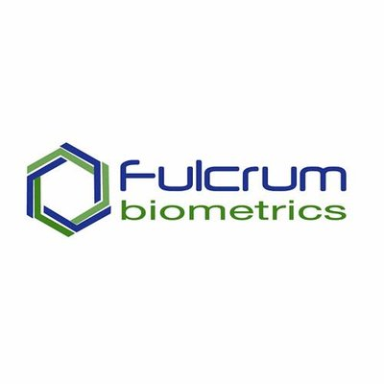 and others  We have R&D collaboration with USA company. By developing a designated SMUFS for the all markets with a card reader and an iris camera on FAP45 TFT technology.    As the largest biometric provider in the world is with SMUFS the OPTICAL version the smallest mobile scanner that can do identification an extraction on device.  Smufs has develop the smallest FBI certified scanner that fits the requirements for mobile phones and tablet (operates with near zero power consumption and full adaptation to its host power management)  Team  President & Founder : Oren Epstein  Mr. Epstein brings 10 years of experience in the biometric industry.Oren led a private fundraising in Exodus, a US-based biometric company focusing on secure payment systems for the healthcare industry.  CTO: Rishi Bhanot  A software engineer with 20 years of hands on experience in biometrics devices. Biometric Embedded Systems and Applications.  Chief operation Officer : Eran Mosaei  Electronic engineer with 20 years’ experience in electronics and computers, that is also in the field of support and services.  Patents  Patent no. IL 218251 regarding secure mobile fingerprint mini-scanner apparatus was approved. An apparatus for fingerprint scanner that is secure, mobile and small. The apparatus is capable of interacting with all smart phones, tablets and PCs. A second patent no. IL219363 was filed and relates to a biometric plug&play server. It is a multi-modal multi algorithms bio matching&recognition system. in processing recorded biometric data in parallel matching process with multiple algorithms. This way the overall FAR&FRR is been reduced to practicality 0. | SMUFS Biometric Solutions Ltd. 2018
Introduction
The evolution of identity technologies has progressed through several distinct stages over the last 30 years. Today the industry finds itself accelerating towards yet another transformation that promises tremendous opportunities for governments and individuals.
Think about how far we’ve come.
Biometric technology is a case in point. It used to exist in a vacuum, and was used in discrete systems by specialists in law enforcement, solely for the purpose of identification. Today, biometrics are deeply integrated with other identity technologies and are part of our everyday lives. We use them to talk on the phone, pay our bills, travel overseas, and receive medical care. The convergence of biometrics with other identity technologies is accelerating their adoption and also their evolution.
Think about where we’re going.
Governments and large organizations were once the drivers and principal users of identity technologies. Today, vast new markets are emerging in commercial and consumer-facing sectors and in offline as well as online domains. With a technical foundation firmly in place, the identity industry is ready to take on the challenge, to think big and to execute.

SMUFS Biometric Solutions is an Israeli startup developing and manufacturing unique mobile biometric hardware and software solutions for integrators and end-users primarily in the mobile domain. SBS patents proprietary (pending) biometric algorithms, software technology and devices, developed in Israel and India. The commercial research, development and headquarters are in the Israeli Negev. Manufacturing is currently done in Thailand. The company is a development partner of Digital Persona, the world’s leading manufacturer of high sensitivity biometric capacitor sensors.

SBS vision
Introduce the world to the economic and environmental benefits of mobile, digital authentication by making it easier for organizations and individuals to adopt biometric authentication. SMUFS makes this a reality by developing a new generation of ultra-reliable, ultra-secure and cost-effective biometric fingerprint solutions that safeguard individual identity, while making solutions more economically viable.

The innovation
We offer: SMUFS Secure Mobile Universal Fingerprint Scanners and NBBS Network Base Biometric Server.
SMUFS Secured mobile fingerprint scanner is a compact, self-powered, standalone fingerprint scanner capable of running over Bluetooth and USB interfaces. It can work with regular computers and laptops over USB, providing PIV certificated images. It can also act as a portable mobile scanner which can be carried, along with your smart phone/tablet. The device can be used in remote areas where access to computers/laptops and internet is limited. By attaching it to any smart phone, it is capable of enrolling new users and even running 1:1 and 1:N matches on the spot through the NBBS server connected over a GPRS network. NBBS exposes the strength of each plugged-in algorithm, while compensating for any weakness by using alternate algorithms. It exposes an easy to use API, which hides the complications of learning different algorithm interfaces. It is capable of extracting and matching finger, face and iris scans.
The founders took the challenge to develop a very reliable and fast authentication system along with access into databases, using multiple, simultaneous unique algorithms.
The development process included design, miniaturization, packaging and server development, using experts in the relevant fields. Unlike existing costly solutions, the company offers full biometric solutions that can stand alone or be integrated with the customer's existing systems. SUMFS offers high quality, easy to use and an easy to implement solutions, at low cost

Applications
The company's solutions are suited for various civil, government and commercial application areas, including: ID document identification, remote worker time/attendance, access control, governments and U.N. food and healthcare distribution, hospitals and health centers, border control/immigration. Disaster scene management, financial and commercial institutions, forensics and many other emerging needs.

The market
“The fingerprint sensor market is expected to grow at a CAGR of 15.66% between 2018 and 2023”

The fingerprint sensor market is expected to grow from USD 4.25 billion in 2018 to USD 8.80 billion by 2023 at a CAGR of 15.66%. The growth of this market is mainly driven by factors such as the proliferation of fingerprint sensors in smartphones and other consumer electronics, government support for the adoption of fingerprint sensors, and use of biometrics in mobile commerce. High potential for fingerprint sensors in IoT applications, and growing scope in the banking and finance industry are the major opportunities for the growth of fingerprint sensor market. However, the adoption rate in developing countries and credibility of users for fingerprint sensor pose restraints for the growth of the market.

Global Mobile Biometrics market is expected to grow at an annual CAGR of 156.9 percent! Over the period 2015-2018 (source: Research and Markets, March 2016). One of the key factors contributing to this booming market is the increasing use of personal devices for financial transactions. Financial institutions, these days are encouraging the use of mobile banking and online financial transactions, thereby increasing the need for high-level security. Since the use of biometrics in mobile devices helps provide high-level security, there has been an increase in the adoption of biometrics in mobile devices. Global Industry Analysts (GIA) market research estimates that the Global Biometrics market will register US$20.47 billion by 2018
The Solution
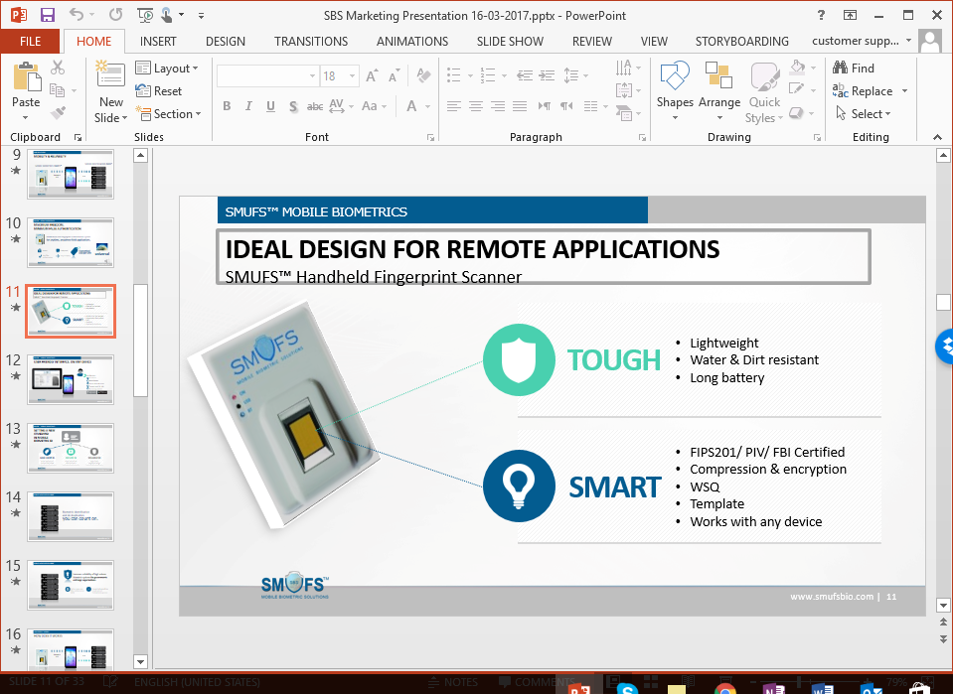
The mobile biometric device called SMUFS (Secure Mobile Universal Fingerprint Scanner) is a secured, mobile, compact, self-powered, standalone fingerprint scanner. It can be used in remote areas where access to computers/laptops and internet is limited.
SMUFS Key features:
Connects easily with any smartphone/tablet/PC via Bluetooth, Wi-Fi or USB.
On board flash allows on board storage and matching capabilities.
FIPS 201/PIV compliant fingerprint sensor suitable for most demanding 1: N authentication challenges.
Raw-image/WSQ/template on device.
How it works
The following chart presents the solution flow:
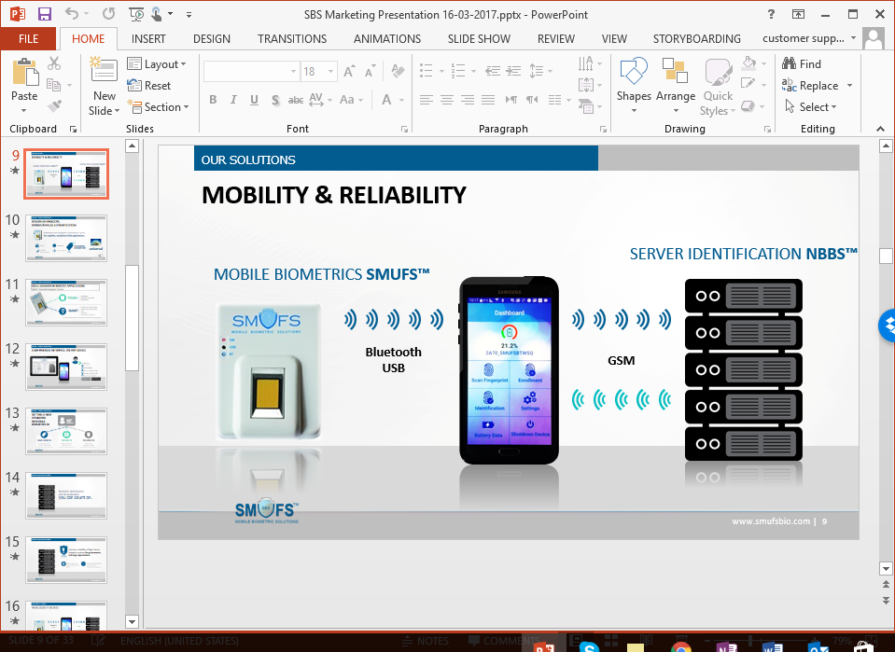
Using the SMUFS, a biometric stamp (fingerprint) is captured and passed to the smartphone using Bluetooth or USB. The smartphone acts as a communication gateway to the NBBS Server that completes the authentication process. The authentication result is presented over the smartphone screen or to any mobile device.

Competitive Analysis
Existing solutions for mobile biometrics scanner devices can conduct only 1:1 injective verification with a low quality image. Existing solutions are much more complex and expensive. To the best of the company's knowledge, there is no direct competitor that offers mobile biometric unit readers with similar level of accuracy and standard-compliance cost. The company reduces costs by using existing capabilities available in smartphone/tablets/laptops. Biometric integrators can then develop any mobile applications over these existing hardware frameworks. SMUFS product is a small stand-alone, handheld unit that is very fast and reliable, using multiple algorithms for identification on the back end. It can be connected to any mobile phone or computer, and priced much lower than competition.

Authentication servers exist in various sizes and configurations. The server is rated according to the level of accuracy in which it can identify a biometric reading and the speed or response. The current solutions require expensive hardware and complex software solutions while using a single authentication algorithm. None of the existing solution provides multiple algorithms that increase the authentication accuracy nor do they use parallel computing to achieve it. Competitors will require a substantial amount of resources and time to reach this level of expertise and experience.

Business Strategy
The market of biometric fingerprint is led by few major companies: 3M Cogent, Digital Persona, Cross-Match and MORPHO. The company's marketing strategy is to cooperate with leading companies in the industry on the basis of OEM, joint development, integration and project-based deals. The company cooperates with Digital Persona and with MORPHO. The company offers b2b and b2c biometric identity solution including biometric scanner device, mobile and server complete software solution. In addition, it offers the biometric scanner unit for companies who wish to integrate it with their solution

