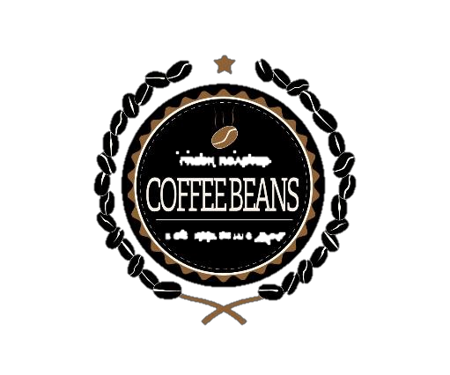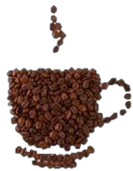

**PREMIUM QUALITY**

**STRONG DEVIL COFFEE**

**NET WT**

9 oz / 250g

**DEVIL STRONG**

THE PODOCARPUS SP. IT IS A TREE SPECIES THAT GIVES SHADOW TO COFFEE. THE NATIVES CALL IT DIABLO FUERTE BECAUSE WHEN THIS DRY CAN NOT BE NAILED OR A NAIL. COFFEE IS PRODUCED IN THE CUSTODY AREA OF YANACHAGA CHEMILLEN NATIONAL PARK, WHERE HUNTING, FISHING AND EXCESSIVE USE OF CHEMICAL PRODUCTS IS PROHIBITED, THE PARK IS THE SOURCE OF WATER FOR OXAPAMPA AND WILD ANIMALS IN DANGER OF EXTINCTION.

**MANUFACTORY BY STRONG DEVIL COFFEE**

**BLACK ROASTED**

**Km. 18.5 HIGHWAY MARGINAL**

**– HUANCABAMBA OXAPAMPA – PERU TELEPHONE: +51 - 956770433**

**R.U.C 20600829981**

**LOTE: 12598 F.V. 30/05/2020**



**PREMIUM QUALITY**

STRONG DEVIL COFFEE

**NET WT**

9 oz / 250g



**DEVIL STRONG**

THE PODOCARPUS SP. IT IS A TREE SPECIES THAT GIVES SHADOW TO COFFEE. THE NATIVES CALL IT DIABLO FUERTE BECAUSE WHEN THIS DRY CAN NOT BE NAILED OR A NAIL. COFFEE IS PRODUCED IN THE CUSTODY AREA OF YANACHAGA CHEMILLEN NATIONAL PARK, WHERE HUNTING, FISHING AND EXCESSIVE USE OF CHEMICAL PRODUCTS IS PROHIBITED, THE PARK IS THE SOURCE OF WATER FOR OXAPAMPA AND WILD ANIMALS IN DANGER OF EXTINCTION.

**MANUF BY STRONG DEVIL COFFEE**

**Km. 18.5 HIGHWAY MARGINAL**

**– HUANCABAMBA OXAPAMPA – PERU TELEPHONE: +51 - 956770433**

**R.U.C 20600829981**

**LOTE: 12598 F.V. 30/05/2020**

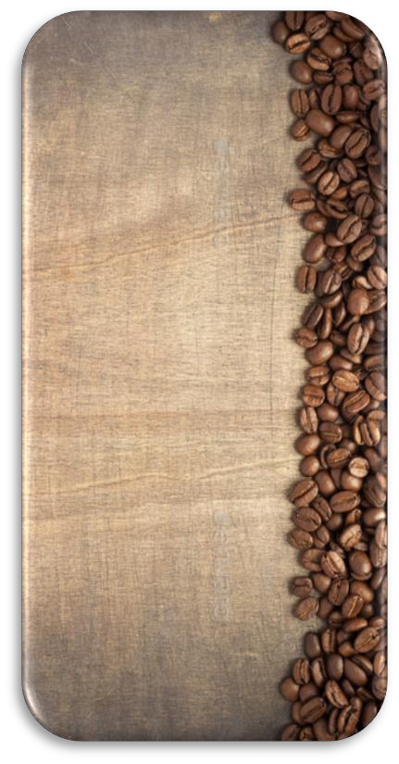

**NET WT**

9 oz / 250g

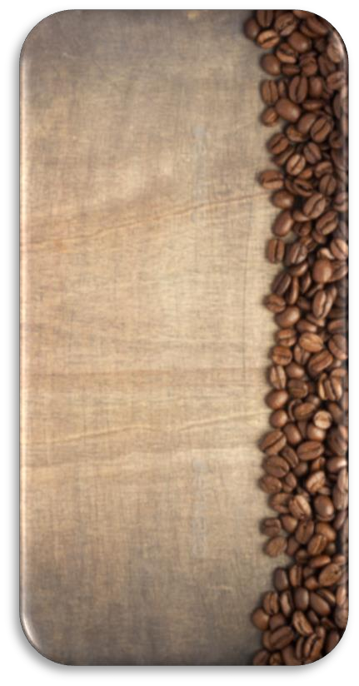

THE PODOCARPUS SP. IT IS A TREE SPECIES THAT GIVES SHADOW TO COFFEE. THE NATIVES CALL IT DIABLO FUERTE BECAUSE WHEN THIS DRY CAN NOT BE NAILED OR A NAIL. COFFEE IS PRODUCED IN THE CUSTODY AREA OF YANACHAGA CHEMILLEN NATIONAL PARK, WHERE HUNTING, FISHING AND EXCESSIVE USE OF CHEMICAL PRODUCTS IS PROHIBITED, THE PARK IS THE SOURCE OF WATER FOR OXAPAMPA AND WILD ANIMALS IN DANGER OF EXTINCTION.

**Km. 18.5 HIGHWAY MARGINAL**

**– HUANCABAMBA OXAPAMPA – PERU TELEPHONE: +51 - 956770433**

**R.U.C 20600829981**

**LOTE: 12598 F.V. 30/05/2020**