زهور الكركديه

HIBISCUS FLOWERS
(Fleurs d’Hibiscus)

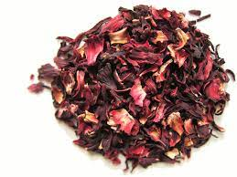
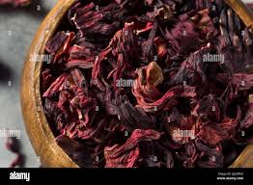

Comments :

